Enabling Software-Defined Networking Technologies in Carrier Networks
Junyu Lai, Bing He, Guolin Sun, Gun Li, Kaiyu Qin
University of Electronic Science and Technology of China
Chengdu 611731, China
Email:{laijy|guolin.sun|binghe|ligun|kyqin}@uestc.edu.cn

Abstract-Adopting software-defined networking (SDN) in carrier networks is now gaining momentum. Carriers and vendors are rushing into this new domain, hoping to solve some most urgent problems which arise along with the process when fixed high-speed data access and mobile broadband (MBB) get increasingly popular across the globe. To the same end, this paper elaborates novel software-defined fixed networking (SDFN) and software-defined mobile networking (SDMN) architectures, leveraging a set of emerging and promising technologies including SDN, clouding computing, network virtualization (NV), network functions virtualization (NFV), and dynamic service chaining. Furthermore, in the light of the irreversible trend towards fixed mobile convergence (FMC), this paper also proposes a forward-looking software-defined converged networking (SDCN) architecture. The three proposed architectures can effectively help carriers to reduce cost and enhance service performance, and therefore can serve as a good reference for the next-generation carrier network designing.
Keywords: Next-Generation Networking Architecture, Network Design, Software-defined Networking (SDN), Carrier Network, Fixed Mobile Convergence (FMC).
- Introduction
SDN refers to an emerging network architecture, which decouples the network control plane and data/forwarding plane. Particularly, control plane is designed to be implemented in software, while data plane is implemented in commercial-off-the-shelf hardware. The industry has already witnessed the successful application of SDN in the fields of data center networking. At present, adopting SDN in carrier networks is gaining gigantic momentum. Carriers and vendors are rushing into this new domain, expecting to solve the most urgent issues and challenges which arise along with the process when fixed high-speed data access and MBB become increasingly popular around the world. More precisely, carriers are mainly annoyed by:
- Ever rising capital expenditure (CAPEX) due to continuous updating of network infrastructure;
- Extremely high operational expenditure (OPEX) owing to complex operation, administration, and maintenance (OAM) tasks in legacy networks;
- Revenue loss as a result of competition with over-the-top (OTT) applications operated by Internet companies;
- Hard to provide finer-granular and differentiated services for both subscribers and applications, since the current carrier networks are not flexible, intelligent and agile enough.
Consequently, the overall challenges from carrier's perspective are to decrease the total cost (CAPEX & OPEX) while enhancing service, so as to increase the revenue.
To help carriers solving the aforementioned problems, quite a few research efforts have been carried out or are ongoing. In industry, Ericsson recently published its Service Provider SDN approach [1], aiming to extend virtualization and OpenFlow with three additional key enablers, i.e., integrated network control, orchestrated network and cloud management, and service exposure. Huawei has also unveiled its SoftCOM strategy [2] for applying SDN and cloud computing in carrier networks. Juniper has developed JunosVContrail SDN product line [3] for carrier networks. In academia, Bansal et al. [4] from Stanford established OpenRadio project, targeting at a programmable wireless network data plane. Li et al. in [5] sketched out a software-defined cellular network architecture called CellSDN. Naudts et al. in [6] conducted a techno-economic analysis of SDN as architecture for the virtualization of a mobile network. In [7], Gudipati et al. recently proposed SoftRAN, a centralized control plane for radio access network (RAN). Pentikousis et al. in [8] introduced the SDN-based MobileFlow architecture.
Many existing proposals only concern one or several specific parts of a carrier network, more detailed holistic solutions for enabling SDN in carrier networks are highly desirable. In order to bridge the gap, this paper elaborates novel SDFN and SDMN architectures for carrier fixed network and mobile network, respectively, leveraging a set of emerging and promising technologies i.e., SDN, clouding computing, network virtualization [9], NFV [10], and dynamic service chaining. Furthermore, in the light of the irreversible trend towards future FMC, the paper proposes a forward-looking SDCN architecture for carriers. It is believed that, as the major contribution, the proposed SDFN, SDMN, and SDCN architectures are of great help for carriers to keep profit and sustainability. Meanwhile, they can significantly enhance both capacity and efficiency regarding network OAM, as well as accelerate business innovation to new application fields.
The remaining part of this paper proceeds as follows. The SDFN and SDMN architectures are proposed in Sections II and III, respectively. In Section IV, this paper further elaborates a future-facing SDCN architecture following both SDN and FMC concepts, aiming to reduce cost while enhancing service for carriers. Finally, conclusions are given in Section V.
- Enabling SDN in Carrier Fixed Networks
Carrier fixed network typically consists of access, aggregation, and core parts (see Figure 1(a)). The increasingly higher access speed demands drive carriers continuously updating their network infrastructure, so as to provide larger bandwidth and better QoS/QoE for subscribers. Nonetheless, each time carriers finish the upgrades with spending vast amounts of money, more bandwidth-hungry applications appear, and subscribers will soon run out the network resources again. This process may never end, and the above incremental up-gradation strategy cannot be sustainable any more. A promising method facing the future is to integrate SDN technologies in carrier fixed networks. Figure 1(b) demonstrates the SDFN proposal, which splits the network data plane and control plan following SDN's principle. The control plan is implemented in the SDN controller cloud, which is a logical entity, built in cloud. By this means, the SDN controllers can enjoy all the conveniences and merits of cloud computing technologies (e.g., scalability & flexibility), and can therefore be implemented in a cost effective matter.
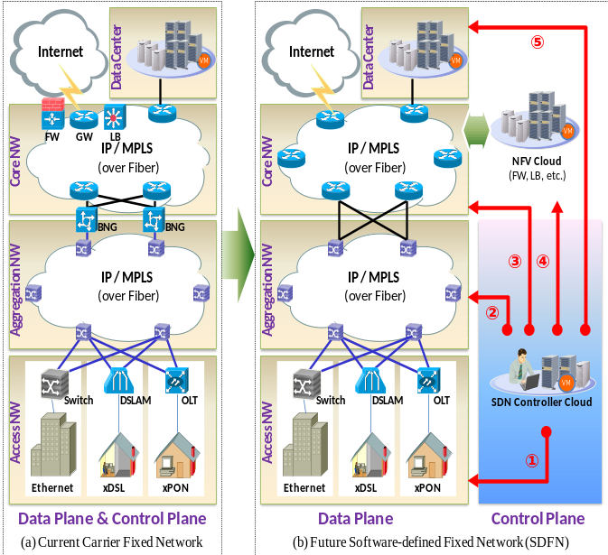
Currently, the access network is dominated by digital subscriber line (xDSL) and passive optical network (xPON) technologies. Taking xDSL for example, xDSL modem is installed in each subscriber premise, working as/with a home-gateway connecting the home-network and its upstream access node (i.e., DSLAM) via local copper loops. Each DSLAM aggregates the traffics of multiple home-networks ranging from hundreds to thousands, depending on different concrete scenarios. With adopting SDN in access network, the control planes of each access node and its downstream home-gateways are separated from the corresponding data planes, centralized and implemented in the SDN controller cloud. In Figure 1(b) Arrow marks the logical control channel to the access network. Carriers then have chances to better control traffic flows in respect of granularity and flexibility, and consequently subscribers can enjoy better QoS/QoE.
Figure 1: Evolution to the SDFN architecture
The aggregation network aggregates the traffics generated by subscribers in access networks to the core network. Although at present there are different types of transport technologies (i.e., SONET/SDH, WDM, MSTP, PTN, OTN, etc.) in use, the trend is to converge towards IP/MPLS over OTN, since it can provide huge bandwidth (e.g. 40Gbps) with high utilization efficiency while still keeping complete OAM and error protection abilities. The aggregation network is usually hierarchically constructed in ring, mesh, or hybrid topologies, with a large geographical coverage in urban/suburban areas. SDN supports are implemented in each aggregation network node, and the corresponding control plan is centralized to be realized in the SDN controller cloud. Arrow in Figure 1(b) denotes the logical control channel to the aggregation network. By doing so, the traffic flows in aggregation network can be conveniently controlled, steered, and manipulated just by simply programming on the control plan, which is extremely useful for carriers to utilize network bandwidth efficiently.
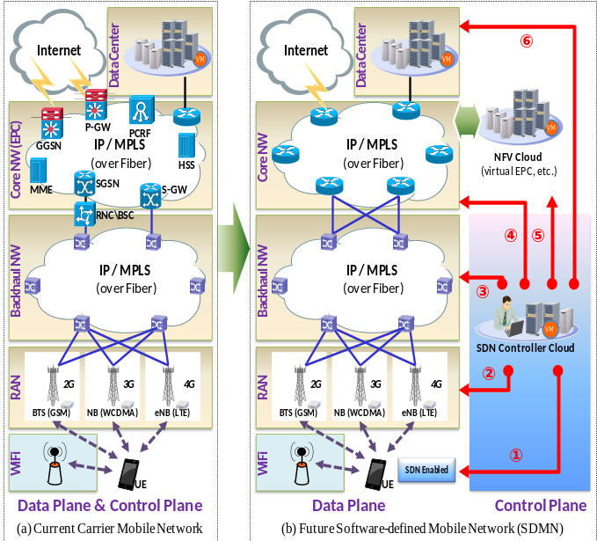
Broadband network gateway (BNG) such as BRAS, typically locates at the edge of core network. BNG provides layer 2 connectivity through either transparent bridging or PPP sessions for subscribers in downstream access networks. It is also the point carriers inject policies and enforce IP QoS managements. Besides, BNG offers layer 3 connections and routes IP traffic through the core network to Internet. In the proposed SDFN architecture, the functionalities of BNG are completely transferred to the NFV cloud. As mentioned, adopting NFV can greatly lower CAPEX/OPEX. Therefore, the other network functionalities previously implemented in dedicated devices, including firewall, load balancing, DPI, etc., in the core network are also moved into the NFV cloud and realized in a more cost-effective way. The rest network nodes in the core network are for traffic forwarding only, on which SDN supports are integrated. The SDN controller communicates with the core network and the NFV cloud via logical channels denoted by arrows and , respectively. This evolved SDFN architecture, compared with the legacy ones, can ensure a better provisioning of application-aware transmission and differentiated services for subscribers with diverse service level agreements (SLAs).
Figure 2: Evolution to the SDMN architecture
Carriers usually build large scale data centers attached to core networks for the purposes such as data caching, Internet data center (IDC) renting, cloud computing, etc. It has already been witnessed that applying SDN inside of data center can be remarkably profitable for carriers. Therefore, in the proposed architectures, the control plane of the data center is decoupled and is moved to the SDN control cloud; the arrow represents the logical SDN control channel.
- Enabling SDN in Carrier Mobile Networks
Carrier mobile network architecture also consists of tree partitions, i.e., RAN, backhaul and core networks. As MBB becomes increasingly popular, subscriber demands on network capacity introduce similar challenges for mobile carriers as those previously introduced in fixed networks. Analogously, SDN is adopted to solve the problems. Figure 2(b) presents a innovative SDMN architecture.
In the RAN part, a multiple radio access technologies (RATs) scenario is assumed, meaning a carrier simultaneously operates 2G, 3G, and 4G mobile networks. Base stations of different RATs co-exist, some of which even collocate at the same sites. Since the radio spectrum is undoubtedly the most precious resource for any mobile carriers, the primary goal of enabling SDN in RAN is to achieve better spectrum resource utilization. In Figure 2(b), a multi-mode UE is capable of concurrently communicating with all the three RATs and WiFi. Firstly, SDN is supported in the UE by e.g., an embedded OpenFlow vSwitch module, with its control plane implemented in the SDN controller cloud of the carrier side. Arrow denotes the corresponding SDN control channel. On that basis, traffic flows of different applications and subscribers can be steered to different RATs (including WiFi) based on the real-time traffic situations of all the RATs. Accordingly, flexible and effective traffic offloading mechanisms can be achieved. Secondly, SDN supports are also realized in base stations of different RATs. More specifically, a part of the control plane which is not related to delay sensitive functions is split and lifted up to the SDN controller cloud, with the abilities to significantly enhance the functionalities needing collaborations between neighbouring cells, such as CoMP and SON. The rest delay-sensitive control functions (e.g., local resource scheduling) are still preserved at each cell site. Arrow marks this SDN control channel. To summarise, adding SDN supports into RAN is essential for mobile carriers to better use the limited radio resource and provide differentiated services for subscribers.
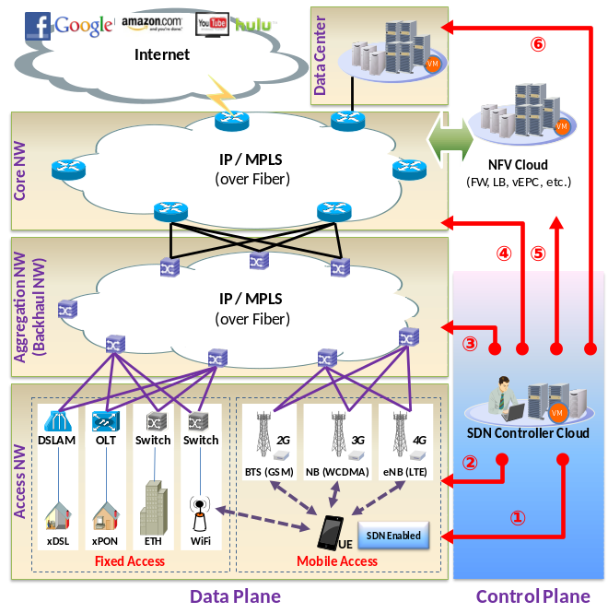
The backhaul network connects base stations and the mobile core. It aggregates traffics of 2G (GSM) and 3G (WCDMA) subscribers towards base station controller (BSC) and radio network controller (RNC), respectively. For 4G LTE, network nodes like BSC or RNC are eliminated with directly implementing the relevant functions in MME and eNodeB. In the trend of IP RAN, the underlying backhaul transport network also evolves to be IP/MPLS over fiber, pretty much the same as the aggregation segment of fixed networks. In fact, the mobile backhaul network and the aforementioned fixed aggregation network can share the same underlying transport network. Consequently, the procedures and advantages of adding SDN supports into mobile backhaul networks are the same as those introduced for the fixed aggregation network in the previous section and will not be repeated.
Figure 3: Evolution to the SDCN architecture
Evolved packet core (EPC) is the latest 3GPP standardised mobile packet core, which contains different sets of functional entities, i.e., S-GW, P-GW, PCRF, MME, etc., for implementing packet data communications for different RATs. Like the current situation in fixed core networks, these functional entities are also implemented in dedicated and vendor-specific boxes, which interpret to be high-cost and inflexible. In Figure 2(b), the aforementioned EPC functionalities are virtualized and are implemented in the NFV cloud. The remaining core network nodes are just for traffic forwarding, and once again their control planes are decoupled and centralized to the SDN controller cloud. In addition, the SDN controller cloud contains the control plane of the NFV cloud too. Arrows and indicate the two different SDN control channels, respectively. The profits brought by this software-defined mobile core are basically the same as those already mentioned above for the software-defined fixed core, and thus are not repeated.
- SDN for Fixed Mobile Convergence
FMC is defined as the merging of fixed & mobile networks and services, and is an effective scheme for carriers to reduce CAPEX&OPEX and to accelerate business innovations. Typically, FMC includes three different levels of merging, i.e., network, service, and terminals [11]. This paper mainly focuses on the network convergence. Presently, the same underlying transport infrastructure (such as SONET, MSTP, WDM, PTN, OTN, etc.) can be shared by both fixed and mobile networks, so to realize FMC at the transport network layer. This convergence can be further extended to the upper IP/MPLS network layer, particularly for aggregation (backhaul) and core networks. However, in access networks, since each access technology belongs to either fixed or mobile network, the network convergence is not applicable.
Based on the SDFN and SDMN architectures proposed above, an SDCN architecture is elaborated and illustrated in Figure 3, which includes both fixed and mobile parts. According to SDN's principle, the control plane of the SDCN architecture is decoupled from the data plane, and is transferred to the SDN controller cloud. Also note that, except the access network segment which contains both fixed and mobile access technologies, the rest parts of the SDCN architecture (including the aggregation and core network segments, as well as the NFV cloud) look almost the same as those in either SDFN or SDMN. The proposed SDCN architecture possesses some vital advantages compared to the legacy fixed & mobile separated networks in the following four aspects:
- Network sharing. By adopting SDN and NV technologies in the SDCN architecture, the underlying physical network, operated by a physical network carrier (PNC), can be easily virtualized and abstracted into multiple slices, each for a virtual network carrier (VNC). By this way, a VNC does not have to construct its own infrastructure but directly rent a network slice from a PNC with a much less cost.
- Traffic offloading between fixed and mobile networks. Currently, the switch between fixed-network-based WiFi and mobile accesses (e.g., 3G) is rather inconvenient. Subscribers usually need operate the switching process manually and experience unpleasant service disruptions. With the inherent global view of both fixed and mobile networks, the SDCN architecture are capable of intelligently and automatically steering traffic flows with different QoE requirements to offload via different paths. Consequently, subscribers can obtain much smoother experience without obvious interruptions. Meanwhile, the global network resource utilization can also be significantly improved.
- CAPEX saving. The SDCN architecture adopts cloud computing and NFV technologies to implement network functional entities on general hardware and software platforms, which significantly reduces CAPEX for carriers.
- OPEX reduction. OAM on legacy networks are quite complex and prone to error; OAM are expensive for carriers who simultaneously operate both fixed and mobile networks. With the SDCN architecture, redundancies of OAM for the fixed and mobile segments are eliminated, and accordingly OPEX can be effectively decreased.
- Conclusions
Recently, due to rapidly growing traffic loads on telecom networks, QoS & QoE are getting increasingly difficult to be satisfied. Meanwhile, carrier revenues are not proportionally increased against their investments; the legacy telecom ecosystem is unsustainable. To tackle with these problems, this paper proposes novel SDFN & SDMN architectures for carrier fixed & mobile networks, respectively. Moreover, this paper elaborates a forward-looking SDCN architecture integrating both fixed and mobile networks. The three proposed architectures can effectively and efficiently help carriers to reduce cost, enhance service performance, and hence act as bridges for the gap between the current carrier network and the next-generation ones.
References
[1] Service Provider SDN. [online] http://www.ericsson.com/news/130227-ericsson-demonstrates-service-provider-sdn-vision-at-mobile-world-congress\_244129229\_c (Accessed 25 March 2014)
[2] J. Patterson. “Huawei SoftCOM: Reshaping the Future of Network Architecture”, Huawei COMMUNICATE, vol. 69, pp. 4-9, (2013).
[3] JunosVContrail. [online]http://www.juniper.net/us/en/dm/junos-v-contrail/ (Accessed 25 March 2014)
[4] M. Bansal, J. Mehlman, S. Katti, et al. “OpenRadio: A Programmable Wireless Dataplane”, Proc. of HotSDN'12, Helsinki, Finland, pp. 109--114, (2012).
[5] L.E. Li, Z.M. Mao, and J. Rexford. “Toward Software-Defined Cellular Networks”, Proc. of EWSDN'12, Darmstadt, Germany, pp. 7-12, (2012).
[6] B. Naudts, M. Kind, F. Westphal, et al. “Techno-economic Analysis of Software Defined Networking as Architecture for the Virtualization of a Mobile Network”, Proc. of EWSDN'12, Darmstadt, Germany, pp. 67-72, (2012).
[7] A. Gudipati, D. Perry, L.E. Li, et al. “SoftRAN: Software Defined Radio Access Network”, Proc. of HotSDN'13, Hong Kong, China, (2013).
[8] K. Pentikousis, Y. Wang, and W. Hu, “MobileFlow: Toward Software-Defined Mobile Networks”, IEEE Communications Magazine, vol. 7, pp. 44-53, (2013).
[9] N.M.K. Chowdhury, R. Boutaba. “Network Virtualization: State of the Art and Research Challenges”, IEEE Communications Magazine, vol. 47, pp. 20-26, (2009).
[10] Network Functions Virtualization. [online] http://portal.etsi.org/NFV/ (Accessed 25 March 2014)
[11] D. Kataria, D. Logothetis. “Fixed Mobile Convergence: Network Architecture, Services, Terminals, and Traffic Management”, Proc. of PIMRC'05, vol. 4, pp.2306-2311, (2005).

